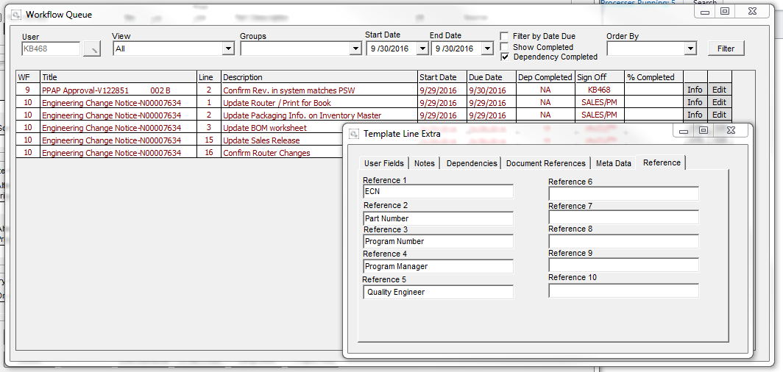

When a workflow kicks off, we would like to have the opportunity to enter information that would get pulled into the Title and/or description of the workflows.

For the ECN workflow, we would like the TITLE to have the following structure.

* ECN (3)-Part Number (20)-Program Number (6)-Program Manager (2)- Quality Engineer (2)

An Example would look like this:

* **ECN-V122851 002-VM0001-KB-KL** (total of 37 characters). Our PN are always 20 characters – 17 for PN and 3 for rev.

Could GS automatically shorten Engineering Change Notice to “ECN” and automatically pull the PN? Then, we could manually enter the Program Number, PM, and QE at time of workflow kick off into reference fields? It the photo above, I am showing everything in reference fields. If we could eliminate the need to enter all of these and only enter Program Manager and Quality Engineer that would be great.

If we can incorporate Program Number, PM, and QE into the ECN tables, could GS also automatically pull that into the title?

For the New Product Release (trigger part), PPAP Approval, and Part obsolete Workflows, we would want the following structure.

* New Product Release **- NPR-V122851 002-VM0001-KB-KL**
* PPAP Approval - **PPAP-V122851 002-VM0001-KB-KL**
* Part Obsolete - **OBS-V122851 002-VM0001-KB-KL**

The KAM program number will be loaded into inventory extra fields. Could you pull it from that table? See below….

So, we would just manually enter the PM and QE in Reference Fields when workflow is kicked off.

